Ex.no:8 | MINI PROJECT – SPORTS  DATA ANALYTICS

Aim:
To clean, transform, store, and analyze IPL ball-by-ball data using Python, MySQL, Power BI and Tableau to derive meaningful insights into match trends, team performance, player performance, batting and bowling statistics, toss decisions, venues, and match outcomes.
Algorithm:
- Load the hotel booking dataset from the CSV file using Pandas.
- Clean the data by handling missing values, removing duplicate records, and eliminating unnecessary attributes.
- Transform the data by standardizing column names and creating useful derived fields such as total runs, wickets, run rate, and match-level statistics.
- Store the cleaned and transformed dataset in a MySQL database named Sports_analytics.
- Connect the MySQL database to Power BI for data analysis and reporting.
- Create DAX measures for key metrics such as total matches, total runs, total wickets, average run rate, and winning teams.
- Develop interactive visualizations to analyze team performance, player performance, scoring trends, toss decisions, venues, and match outcomes.
- Generate business insights from the Power BI & Tableau dashboard.
- End the process.

Architecture:

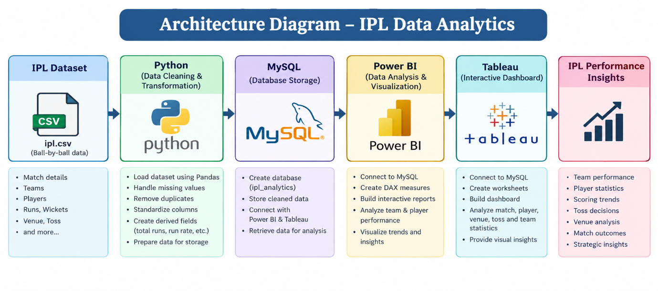

Program:
1. Python – Data Cleaning & Transformation
import pandas as pd
from sqlalchemy import create_engine, text

# Load dataset
df = pd.read_csv("ipl.csv", low_memory=False)

# Create a copy for processing
ipl = df.copy()

# Remove duplicate records
ipl.drop_duplicates(inplace=True)

# Handle missing values
ipl["city"] = ipl["city"].fillna("Unknown")
ipl["venue"] = ipl["venue"].fillna("Unknown")
ipl["player_of_match"] = ipl["player_of_match"].fillna("Unknown")
ipl["winner"] = ipl["winner"].fillna("No Winner")
ipl["result"] = ipl["result"].fillna("Unknown")

# Fill numerical missing values
ipl["result_margin"] = ipl["result_margin"].fillna(0)
ipl["runs_scored"] = ipl["runs_scored"].fillna(0)
ipl["extras"] = ipl["extras"].fillna(0)

# Convert date column
ipl["date"] = pd.to_datetime(ipl["date"], errors="coerce")

# Create total runs
ipl["total_runs"] = ipl["runs_scored"] + ipl["extras"]

# Create run rate
ipl["run_rate"] = (
ipl["current_score"] /
((ipl["over"] * 6 + ipl["ball"]).replace(0, pd.NA) / 6)
)

# Standardize column names
ipl.columns = (
ipl.columns
.str.lower()
.str.strip()
.str.replace(" ", "_")
)

# Display dataset information
print("Original Shape:", df.shape)
print("Cleaned Shape:", ipl.shape)
print(ipl.head())

2. MySQL – Database and Data Loading
MySQL Command Prompt:
net start MySQL80
mysql -u root -p
MySQL:
CREATE DATABASE IF NOT EXISTS ipl_analytics;
Python/Jupyter:
username = "root"
password = "YOUR_MYSQL_PASSWORD"
host = "localhost"
port = 3306

# Connect to MySQL database
db_engine = create_engine(
f"mysql+pymysql://{username}:{password}@{host}:{port}/ipl_analytics"
)

# Load cleaned data into MySQL
ipl.to_sql(
"ipl_matches",
con=db_engine,
if_exists="replace",
index=False,
chunksize=5000
)

print("Data loaded successfully into MySQL.")
Verify:
pd.read_sql(
"SELECT COUNT(*) AS total_rows FROM ipl_matches",
db_engine
)
3. Power BI – DAX Measures
Total Matches =DISTINCTCOUNT('ipl_analytics ipl_matches'[match_id])

Total Runs =SUM('ipl_analytics ipl_matches'[total_runs])

Total Wickets =
COUNTROWS(
FILTER(
'ipl_analytics ipl_matches',
NOT ISBLANK('ipl_analytics ipl_matches'[player_out])
)
)

Average Run Rate =AVERAGE('ipl_analytics ipl_matches'[run_rate])

Total Sixes =CALCULATE(COUNTROWS('ipl_analytics ipl_matches'),
'ipl_analytics ipl_matches'[runs_scored] = 6
)
4. Tableau Dashboard
Created visuals in tableau in separate sheets and created a dashboard

Output:
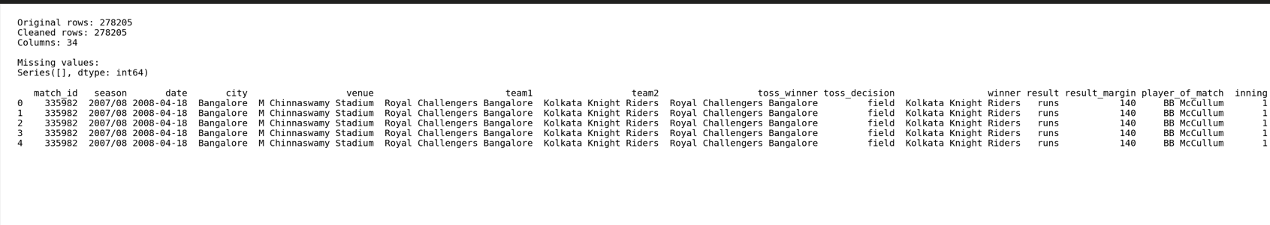

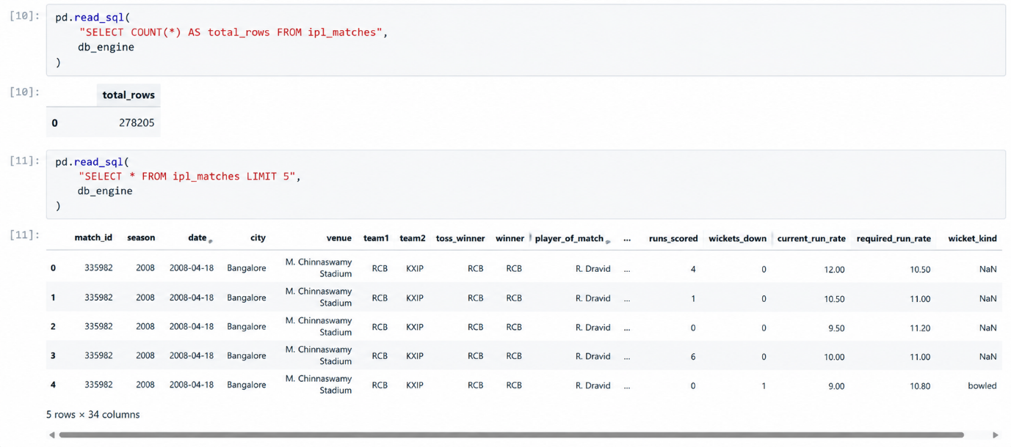

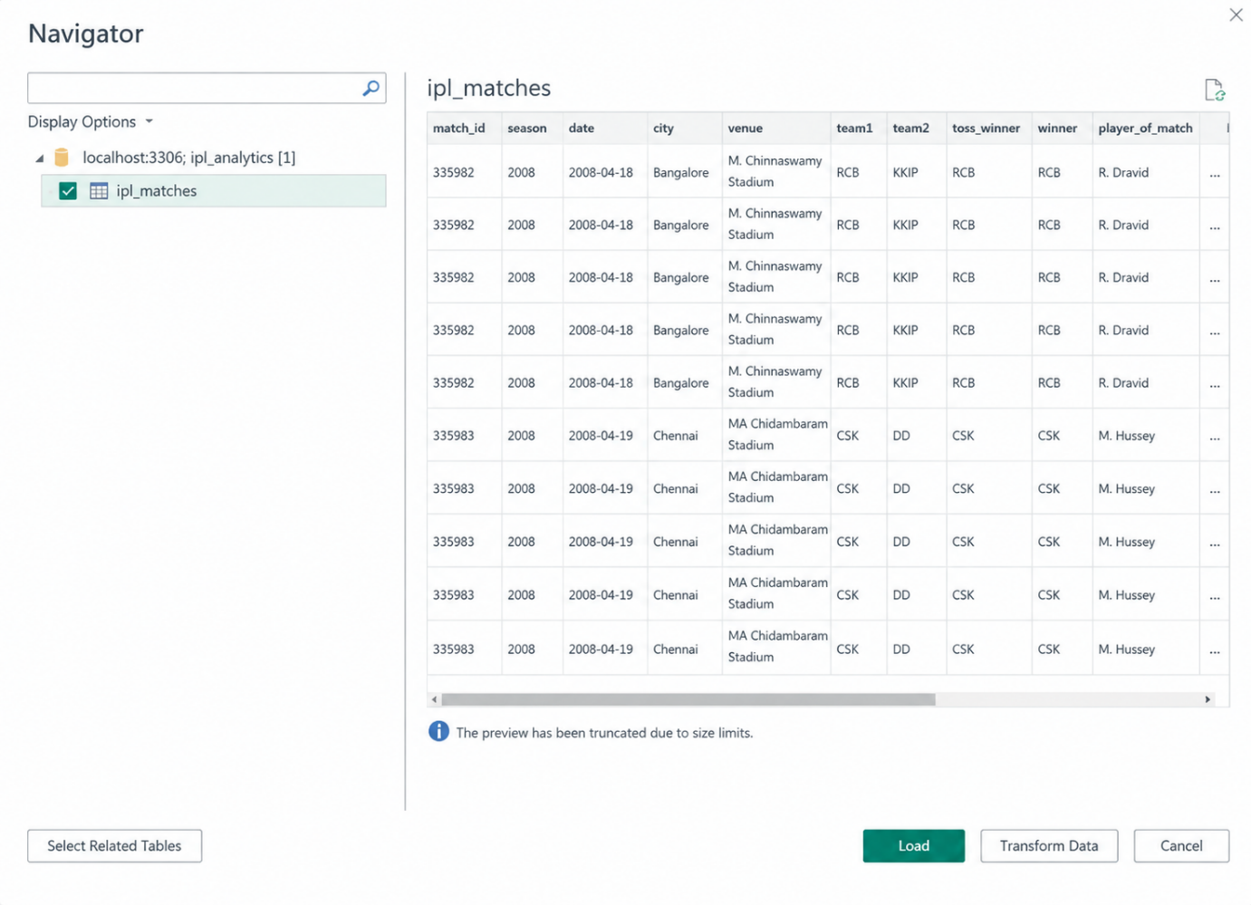

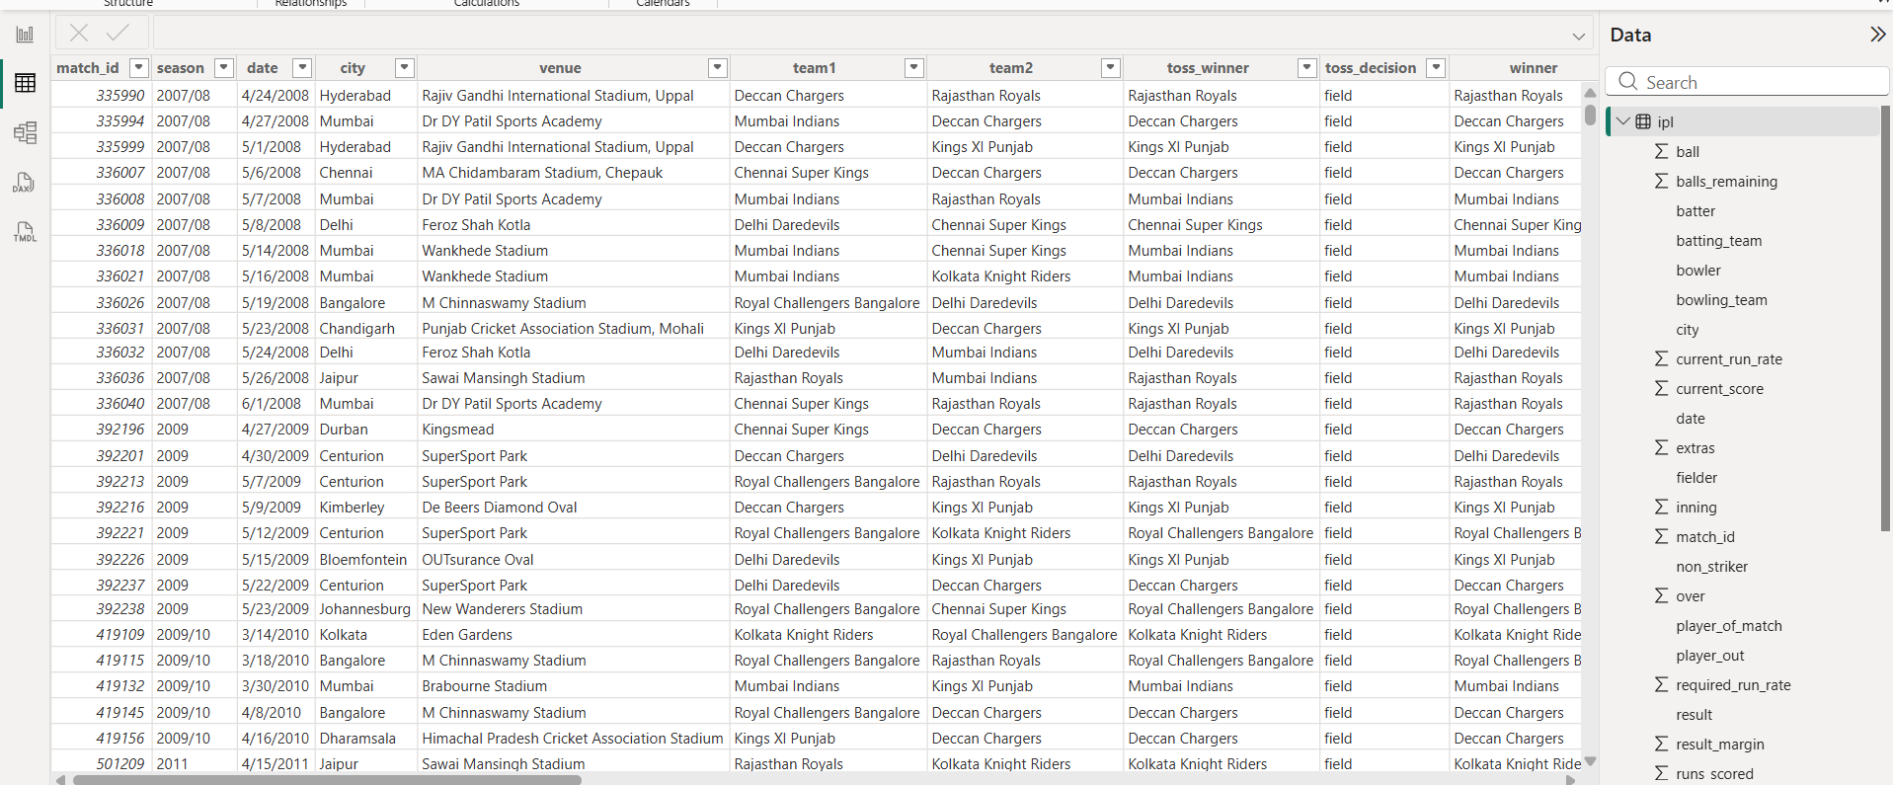

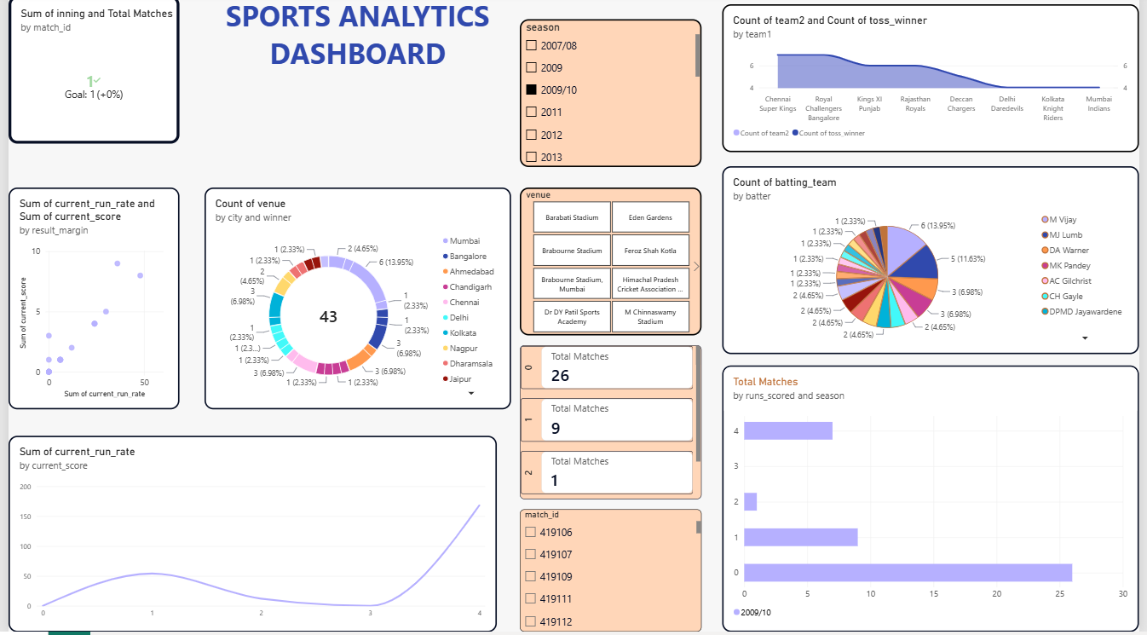

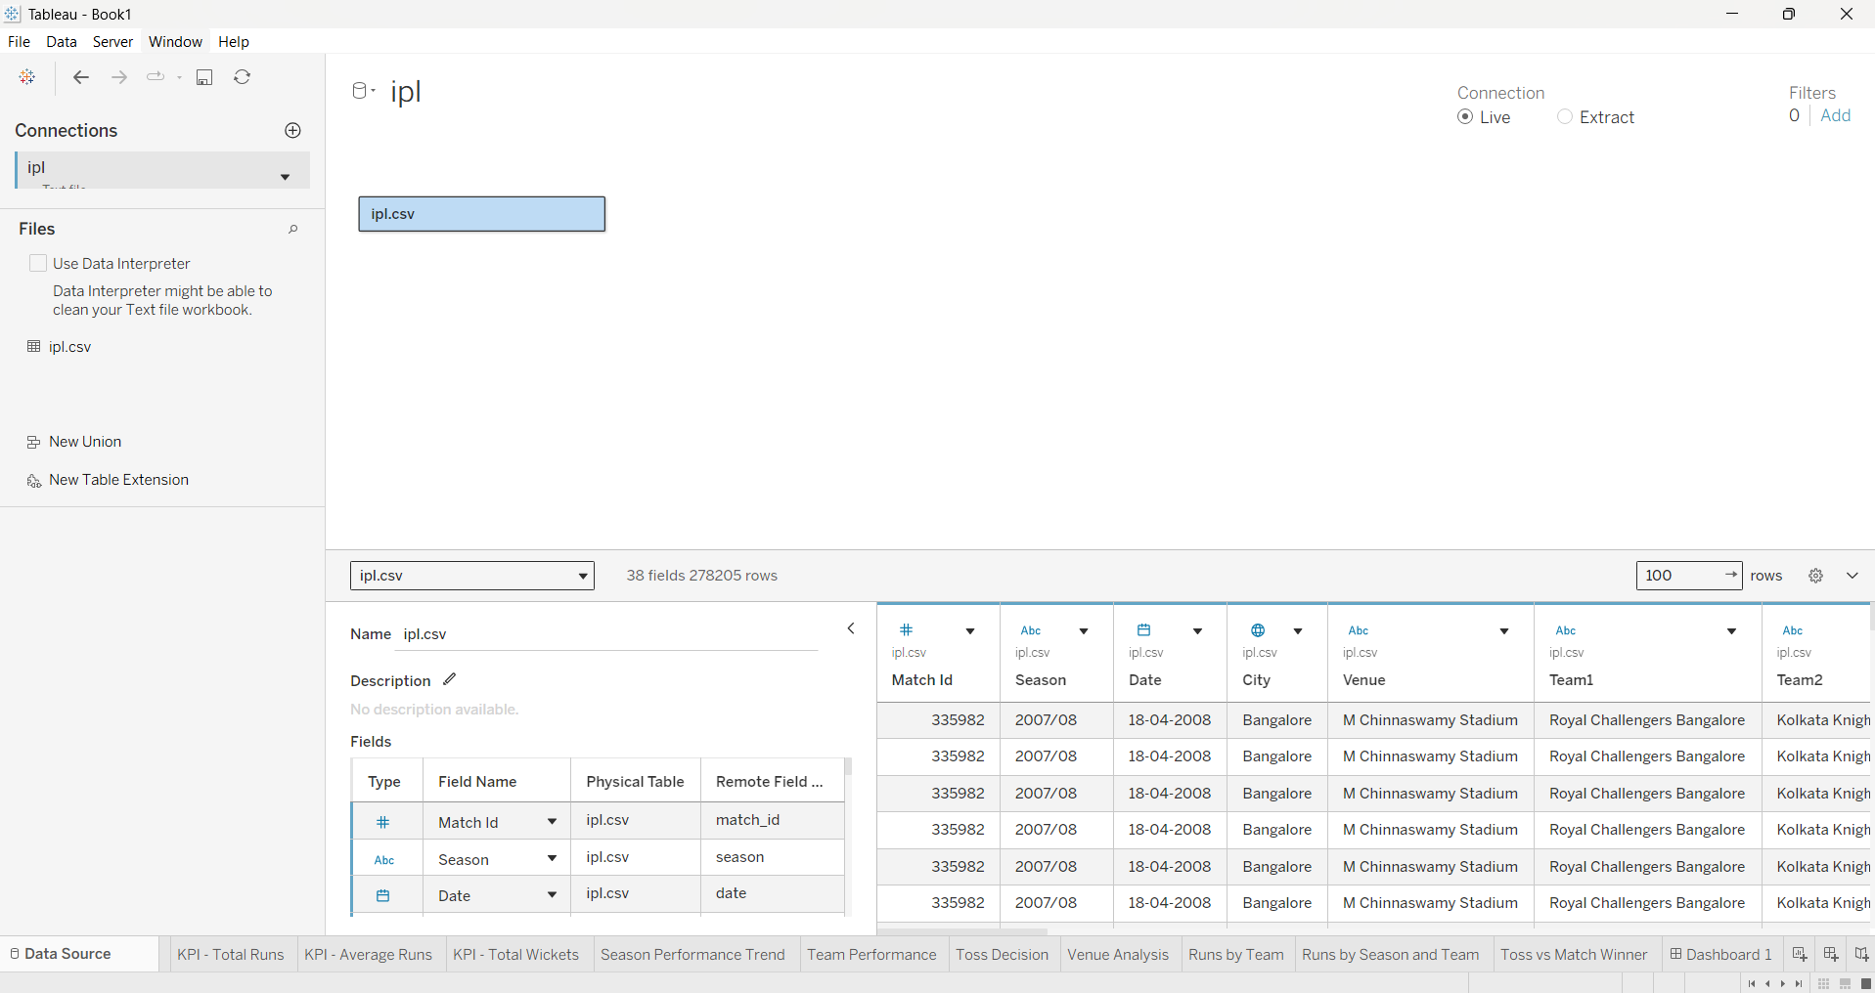

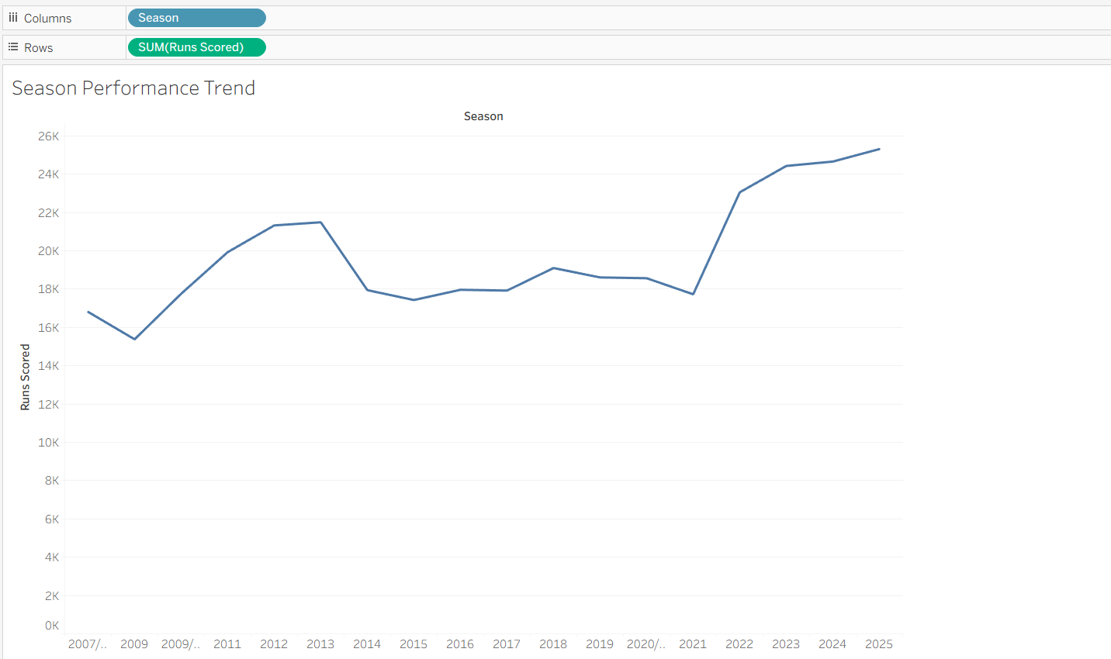

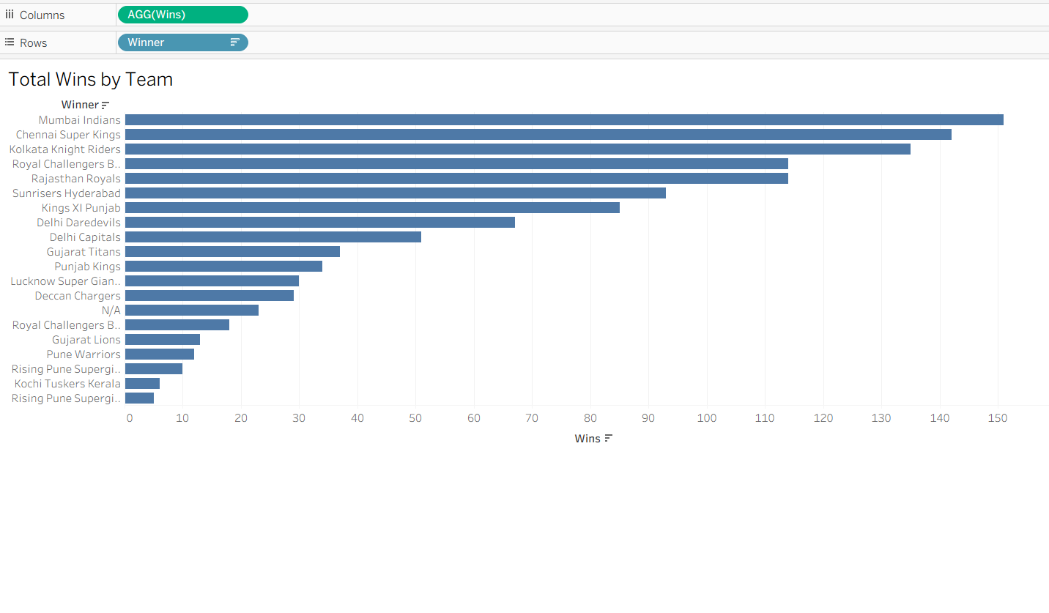

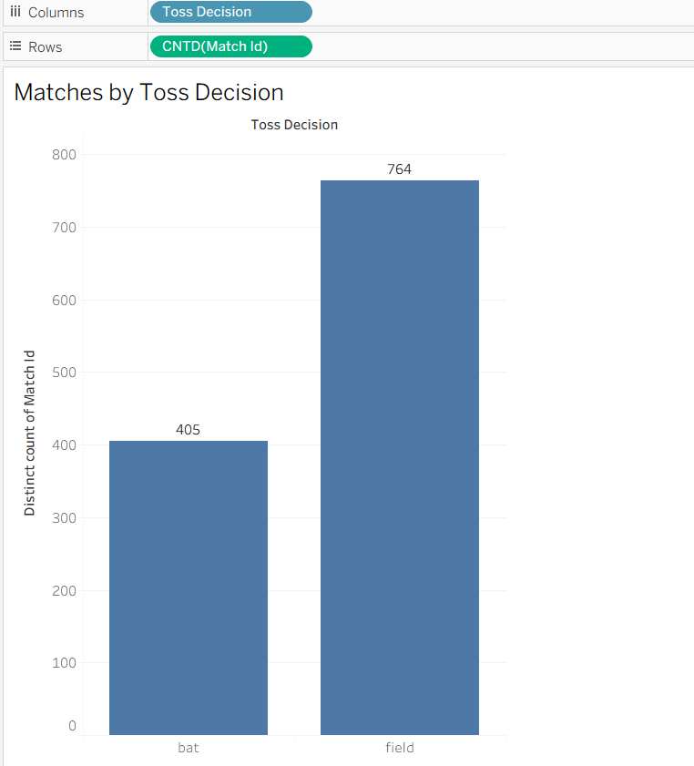
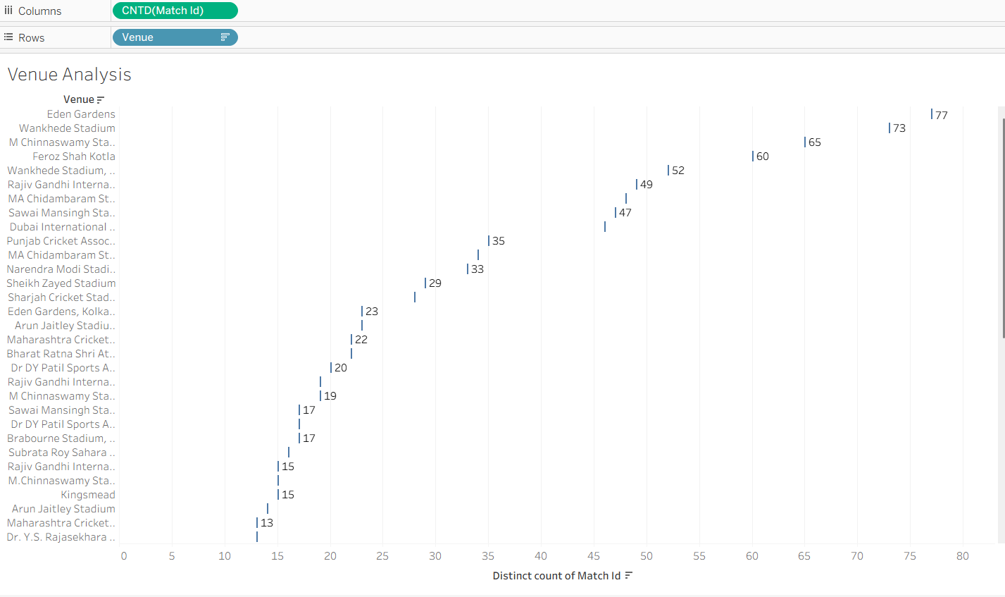

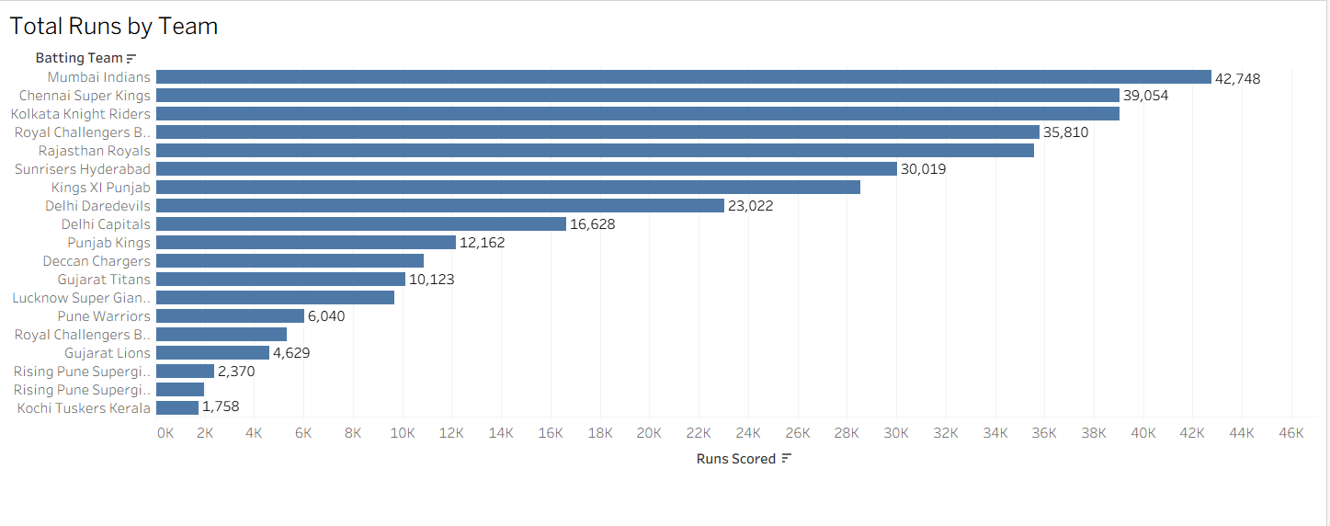

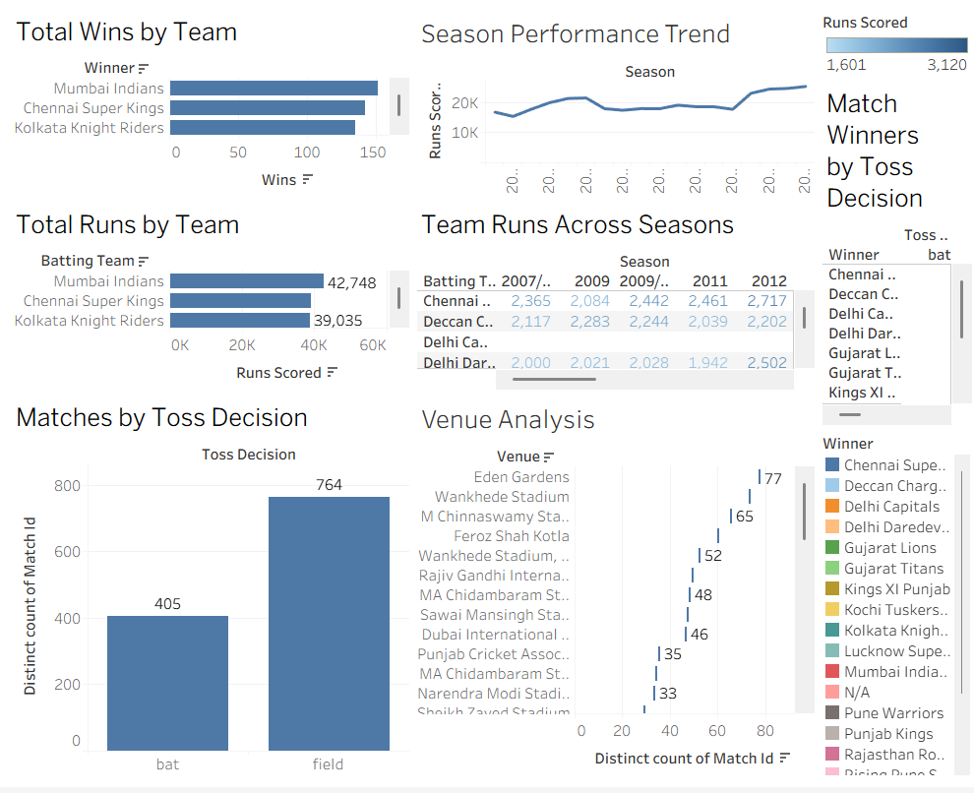

Result:

